

**Department of Computing**

**Sentiment Analysis Of Customer Feedback Of Phones Using Hybrid Neural Networks**

**(Development Project -** [**55-608850-AF-20234**](https://shuspace.shu.ac.uk/webapps/blackboard/execute/courseMain?course_id=_346902_1)**)**

**Student Name:** Kemas Raihan

**Student ID:** 26024493

**Supervisor Name:** Zairul Jilani

**Word Count:** 3235

**Abstract**

Customer feedback expressed in websites, such as Reddit, do not have an integrated rating system, making them textual data that lacks structure, is large, and is difficult to analyse manually. Nonetheless, in the realm of sentiment analysis, hybrid neural networks have shown to be ideal models for reducing sentiment errors on increasingly complex training data. This report aims to test the reliability of several hybrid neural networks on textual datasets. The research questions are aimed at determining whether it is possible to produce hybrid models that outperform traditional non-hybrid models with the same dataset. Hybrid deep sentiment analysis learning models that combine convolutional neural networks (CNN) with Long-Short Term Memory (LSTM) or Bidirectional Long-Short Term Memory (Bi-LSTM) are built and tested on hundreds of Amazon review datasets and evaluated on traditional machine learning metrics such as accuracy, precision, recall and f1. The hybrid models are compared against three baseline models that make them: CNN, LSTM and BiLSTM. Training time was also measured to also evaluate time-accuracy balance. In the end, the hybrid models showed slight improvement in terms of accuracy when it comes to the CNN + LSTM model but took longer time to train. In this report, Section 2 will address the literature survey related to my project. Afterwards, section 3, will provide details of the proposed solution. Section 4 will discuss legal, ethical and social issues and how they will be addressed in the project. Finally, section 5 and 6 will discuss the conclusion of the research and suggestions for improvement, respectively.

**Table of Contents**

**1. Problem Statement 3**

**2. Literature Review 3**

2.1 Preprocessing Techniques 3

2.1.1 Word Embedding 3

2.1.2 GloVe Embedding 4

2.2 Sentiment Analysis Algorithms 4

2.3 Neural Networks In Sentiment Analysis 5

2.3.1 Convolutional Neural Networks (CNN) 5

2.3.2 Long-Short Term Memory (LSTM) 5

2.3.3 Bidirectional Long-Short Term Memory (Bi-LSTM) 6

2.4 Hybrid Algorithms In Sentiment Analysis 6

**3. Proposed Solution 7**

**4. Legal Social and Ethical Issues 7**

4.1 Legal Issues 7

4.2 Social Issues 8

4.3 Ethical Issues 8

4.4 Impact on Design and Development of Deliverable 9

4.4.1 Mitigating Confidentiality 9

4.4.2 Protecting Copyright Infringement 9

4.4.3 Implement Transparency 9

4.4.4 Reducing Bias 9

4.4.5 Promote Genuine Expression 10

**5. Evaluation of the Finished Product 10**

**6. Conclusion 12**

**7. Suggestions For Improvement 12**

**Appendix 13**

Source Code 13

**References 13**

# Problem Statement

In today’s digital age, smartphones have become a part of our everyday lives and now over half (54%) of the global population – some 4.3 billion people – now owns a smartphone according to [GSMA (2023)](https://www.gsma.com/r/somic/). Moreover, new smartphones are released every year and the mobile phone market is filled with a plethora of choices, making it important for manufacturers and service providers to dissect customer preferences and concerns accurately. In fact, according to [Laricchia (2023)](https://www.statista.com/statistics/263437/global-smartphone-sales-to-end-users-since-2007/) almost 1.4 billion phones were sold in 2024 alone.

Given the popularity of social media and the availability of smartphones with user-friendly apps, many customers are giving feedback to the latest phone product in the market, in the form of online reviews. Customer reviews have always been a critical business application, which allows the company to determine client attitude towards its products. It emphasises a detailed examination of the customer's perspective on the business entity, as customer happiness is constantly used to measure corporate performance. The introduction of a new phone has always been based on examination of customers' opinions on existing phones.

Fortunately, review websites such as Amazon and Yelp, allows users to provide ratings giving a more direct sentiment. However, many customers prefer to use social media and forum sites such as Twitter and Reddit to provide their feedback, which lack an integrated rating system. This leads to textual data which lacks structure, is large, and is difficult to analyse manually, necessitating the employment of Big Data techniques such as sentiment analysis. Such technology has been widely used to predict customer sentiment in reviews However, sentiment analysis that is custom to longer and more nuanced reviews is still lacking especially in novel algorithms.

# Literature Review

Machine learning developers have long been creating systems that can download, organise, and analyse text from online reviews by creating machine learning algorithms to perform sentiment analysis ([Liu, 2020, 1-17](https://www.cambridge.org/core/books/abs/sentiment-analysis/introduction/563742A639EEE9F5AB3F29CB2387E41C)). The majority of the existing studies have built these machine learning algorithms from scratch. This section will look at similar projects and research that have been conducted in the past.

## 2.1 Preprocessing Techniques

Textual data must undergo preprocessing to be transformed into numerical values, in order for it to undergo classification ([Haddi et al., 2013](https://www.sciencedirect.com/science/article/pii/S1877050913001385)). Afterwards,these individual words undergo what is known as word embedding.

### 2.1.1 Word Embedding

Word embedding uses two words that are related should have similar values in a projected vector space ([Hui, 2019](https://jonathan-hui.medium.com/nlp-word-embedding-glove-5e7f523999f6)). Several techniques in word embedding include Word2vec and BERT where [Dang et al. (2021)](https://www.hindawi.com/journals/complexity/2021/9986920/#references) applied both on eight textual datasets of tweets and reviews. Similarly, [Muntinda et al. (2023)](https://www.mdpi.com/2076-3417/13/3/1445) used 250-dimensional Word2Vec embeddings trained on Wikipedia, and 128-dimensional BERT embeddings trained on English Wikipedia corpus to convert text reviews into numeric vector forms. In contrast, [Obiedat et al. (2022)](https://ieeexplore.ieee.org/document/9706209) employed the bag-of-word technique, effectively converting text data into a numerical format suitable for algorithmic input.

### 2.1.2 GloVe Embedding

[Pennington et al. (2014)](https://nlp.stanford.edu/pubs/glove.pdf) has shown that GloVe outperforms other models on word analogy, word similarity, and named entity recognition tasks. In the study, for the same corpus, vocabulary, window size, and training time, GloVe consistently outperforms Word2vec. It achieves better results faster, and also obtains the best results irrespective of speed.

## 2.2 Sentiment Analysis Algorithms

Many studies have built sentiment analysis algorithms from scratch. One such study includes [Zhan & Fang (2015)](https://journalofbigdata.springeropen.com/articles/10.1186/s40537-015-0015-2#citeas), who used baseline algorithms such as Naive Bayes, Decision Trees and Support Vector Machines to perform sentiment analysis on Amazon reviews. Before the textual data was used to train the models, they used part-of-speech (POS) taggers ([Pykes, 2020](https://towardsdatascience.com/part-of-speech-tagging-for-beginners-3a0754b2ebba)), allowing the sentiment analysis algorithms to easily identify the function of each word in a sentence. Afterwards, they evaluated each classification model based on its averaged F1-score ([Hand, 2020](https://arxiv.org/abs/2008.00103)). The averaged sentiment score was found to be a strong feature on its own, as it achieved an F1 score of more than 0.8 for sentence-level categorization with the entire set. For review-level categorization with the entire set, the feature can produce an F1 score greater than 0.73. However, one of those limitations of the study was that categorising reviews at the review level becomes difficult if the reviews are to be classified based on their star ratings. In other words, the F1 scores obtained from such experiments are relatively low, with values less than 0.5.

On the other hand, [Ahmed & Rodríguez-Díaz, (2020](https://www.mdpi.com/2071-1050/12/20/8683)) used multiple regression analysis to perform sentiment analysis on customer reviews of Airlines. The findings confirm that multiple regression analysis is adequate for evaluating clients' sentiments. The availability of a quantitative reference variable is required to evaluate the sign and intensity of the sentiments, and that the number of labels used to evaluate clients' sentiments can be reduced based on their roots and levels of significance in relation to the quantitative reference variable.

Alternatively, some researchers have applied built-in tools to perform sentiment analysis, such as [Prananda & Thalib, (2020)](https://www.researchgate.net/publication/341079068_Sentiment_Analysis_for_Customer_Review_Case_Study_of_GO-JEK_Expansion) who used Microsoft Text Analytic for labelling sentiments in twitter posts to examine sentiment towards GO-JEK’s customer services. Meanwhile ([Kwon et al., 2021](https://www.mdpi.com/2078-2489/12/2/78)) used Opinion Lexicon to classify the sentiments. On the other hand, some researchers have utilised deep learning techniques, namely neural networks.

## 2.3 Neural Networks In Sentiment Analysis

Neural networks have been widely used in sentiment analysis ([Spring Nation, 2023](https://link.springer.com/article/10.1007/s42979-021-00815-1)) as they are built for complex machine learning problems as deep learning techniques are known to be effective and widely used in the realm of sentiment analysis as they can learn hierarchical representation and capture complex patterns in text data ([Trends and Surveys, 2023](https://link.springer.com/article/10.1007/s13735-023-00308-2)). Two types of neural networks have been commonly used in sentiment analysis, mainly Convolutional Neural Networks (CNN) and Long-Short Term Memory (LSTM).

### 2.3.1 Convolutional Neural Networks (CNN)

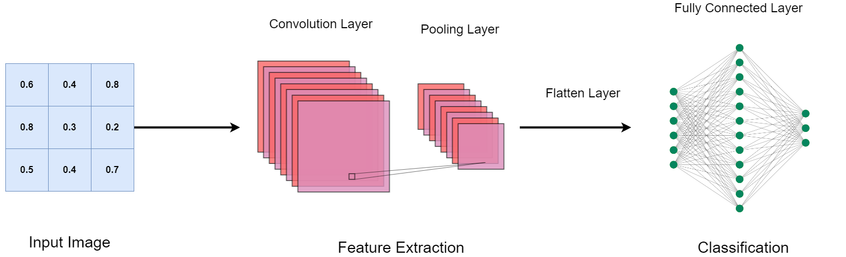

Figure 2.1 - Layers in a typical convolutional neural network.

Recent studies have shown that Convolutional Neural Networks (CNN) (Aggarwal, 2019, p305) can produce promising results in natural language processing. For example, [Nedjah et al. (2023)](https://link.springer.com/article/10.1007/s12065-019-00227-4#Sec5) has produced a sentiment analysis classifier using convolutional neural networks by analysing the impact of the hyper-parameters on the model performance. Moreover, [Annareddy & Tammina, (2009)](https://ieeexplore.ieee.org/stamp/stamp.jsp?tp=&arnumber=9104086&isnumber=9104045) demonstrated accuracy results to show that their word2vec and CNN algorithm is more efficient than Naive Bayes and Random Forest when it comes to sentiment analysis of product reviews.

### 2.3.2 Long-Short Term Memory (LSTM)

[Iqbal et al. (2022)](https://www.mdpi.com/1805800) applied Long-Short Term Memory (LSTM) ([Grossberg, 2013](http://scholarpedia.org/article/Recurrent_neural_network)), which have been designed to model temporal sequences and their long-range dependencies more accurately than conventional RNNs ([Sak et al., 2014](https://static.googleusercontent.com/media/research.google.com/en//pubs/archive/43905.pdf)), to perform sentiment analysis on consumer reviews and experimented on different network architecture and parameters of the LSTM architecture.

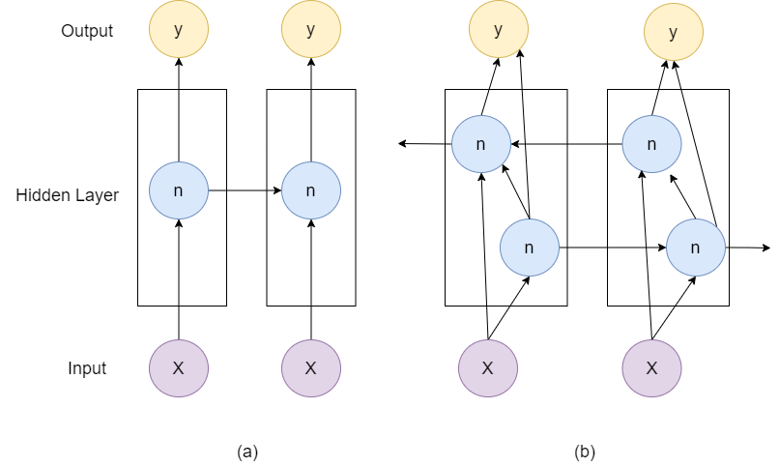

Figure 2.2 - Configuration of (a) LSTM network (b) Bi-LSTM network

### 2.3.3 Bidirectional Long-Short Term Memory (Bi-LSTM)

There are several instances where BiLSTM ([Berglund et al., 2015](https://proceedings.neurips.cc/paper_files/paper/2015/file/c75b6f114c23a4d7ea11331e7c00e73c-Paper.pdf)) are used in Sentiment analysis. [AlQahtani (2021)](https://aircconline.com/ijcsit/V13N3/13321ijcsit02.pdf) trained a Bidirectional Long-Short Memory (Bi-LSTM) with GloVe embedding and joint-learned embedding to perform sentiment analysis on Amazon product reviews, along with other baseline machine learning algorithms such as Logistic Regression, Random Forest, Naïve Bayes and BERT. They evaluated each model using different evaluation metrics including Cross Entropy Loss, Accuracy, Precision, Recall, F-score. The Bi-LSTM model showed excellent results: having accuracy of 93% for multiclass classification and 97% for binary classification. However, the BERT model outperformed other classification models. For binary classification, the BERT model in binary classification has the highest accuracy compared to other models.

## 2.4 Hybrid Algorithms In Sentiment Analysis

[Obiedat et al. (2022)](https://ieeexplore.ieee.org/document/9706209) addressed the challenges of imbalanced data by proposing a hybrid approach combining Support Vector Machines (SVM) and Particle Swarm Optimization (PSO). [Priyadarshini & Cotton (2021)](https://link.springer.com/article/10.1007/s11227-021-03838-w#Sec19) proposed a LSTM-CNN grid search-based deep neural network. Furthermore, [Dang et al. (2021)](https://www.hindawi.com/journals/complexity/2021/9986920/#references) built a hybrid model of SVM, CNN, and LSTM. As a result, by utilising evaluation metrics using accuracy and f1-scores, [Obiedat et al. (2022)](https://ieeexplore.ieee.org/document/9706209) found that their hybrid PSO-SVM model provided better results than the standard SVM, LR, RF, DT, k-NN, and XGBoost in all versions of the datasets. Similarly, [Priyadarshini & Cotton (2021)](https://link.springer.com/article/10.1007/s11227-021-03838-w#Sec19) and [Dang et al. (2021)](https://www.hindawi.com/journals/complexity/2021/9986920/#references) have also demonstrated that their hybrid models also outperformed all other existing ones. For binary classification, the BERT model in binary classification has the highest accuracy compared to other models.

# 3. Proposed Solution

My solution is to create my own original sentiment analysis model by combining two different types of neural networks, hence creating a hybrid model. I will utilise three different types of neural networks: CNN, LSTM and BiLSTM to create two hybrid models: CNN + LSTM and CNN + BiLSTM. Then,I will define my evaluation metrics to compare my existing hybrid models with the three baseline neural networks as mentioned. Thus, I will utilise evaluation metrics like F1-score, accuracy, precision and recall for all the models and compare the performances of my hybrid models with the non-hybrid ones to see if there is any improvement from the hybrid models to the non-hybrid ones and see which hybrid model is the most efficient one. Afterwards, In terms of scalability and efficiency, I will measure factors such as training time, inference speed and resource requirements. Finally, I will test the model’s performance on unseen data from similar domains to assess its generalizability.

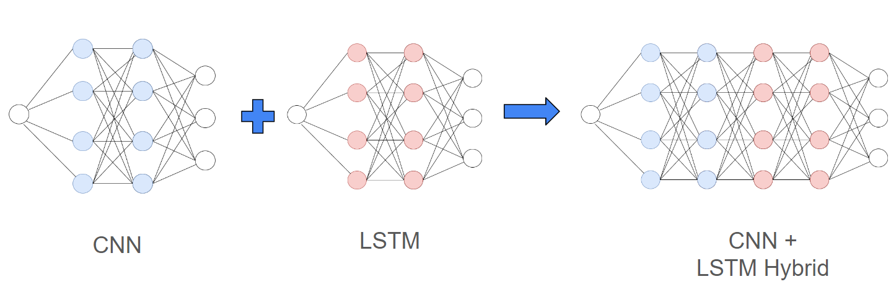

Figure 3.1 - an example of a CNN and LSTM neural network hybrid, where unique layers of each neural network are combined to create the CNN + LSTM hybrid.

# 4. Legal Social and Ethical Issues

This section will provide legal, social and ethical issues regarding my final deliverable and how they have impacted on how I designed and developed my deliverable.

## 4.1 Legal Issues

* **Privacy Concerns:** By using Amazon customer reviews, I could access and process the personal data of each customer. This will raise privacy issues if not handled in compliance with GDPR (General Data Protection Regulation). Furthermore, websites that handle personal data are vulnerable to hackers gaining unauthorised access ([McCallum & Tidy, 2023](https://www.bbc.co.uk/news/technology-67624182)).
* **Model Confidentiality:** The sentiment analysis model contains sensitive algorithms, so I need to prevent unauthorised access or reverse engineering from malicious actors.
* **Copyright Infringement:** Utilising customer reviews for sentiment analysis may involve quoting or copying text. This could infringe the copyright of the reviewers without being granted appropriate permissions or fair use principles. According to [Barker (2024)](https://tracefuse.ai/blog/can-i-use-amazon-reviews-on-my-website/#is-it-legal-to-use-amazon-reviews-on-my-website), Amazon reviews are legally owned by the users who wrote them and could result in utilising Amazon reviews on your website without their consent could breach Amazon’s terms and conditions, potentially resulting in penalties or other repercussions.

## 4.2 Social Issues

* **Trust and Credibility:** If sentiment analysis results are misinterpreted or misused, it could undermine trust in the analysis process and the technology involved.
* **Consumer Influence:** Public sentiment analysis of Amazon reviews could influence consumer behaviour, potentially shaping purchasing decisions based on influence of other customer’s sentiments rather than the quality of the product. Furthermore, negative sentiment analysis results could harm businesses’ reputation or sales, leading to ethical considerations about the consequences of sharing such insights. Although this is beyond my control, it is not my responsibility to ensure that the products remain of high quality. My model is just building upon past reviews.
* **Impact on Review Culture:** Analysing reviews en masse and reducing them into mere sentiments may overshadow opinions and discourage genuine expression, which could result in a negative influence to the whole online review culture.

## 4.3 Ethical Issues

* **Consent and Transparency:** Users may not be aware that their reviews are being used for sentiment analysis.
* **Bias and Fairness:** Sentiment analysis algorithms can be prone to bias, potentially leading to unfair treatment of certain products, brands, or customers. ([Kiritchenko & Mohammad, 2018](https://arxiv.org/abs/1805.04508)) has shown that several sentiment analysis algorithms have shown statistically significant bias; that is, they consistently provide slightly higher sentiment intensity predictions for one race or one gender.
* **Manipulation of Reviews:** If sentiment analysis is used to manipulate or influence customer reviews, it could raise ethical concerns on authenticity and transparency.

## 4.4 Impact on Design and Development of Deliverable

### 4.4.1 Mitigating Confidentiality

In terms of confidentiality, in my raw dataset, neither personal nor account information is employed, thereby mitigating confidentiality concerns. However, to protect my model from attackers I could use symmetric encryption: a technique in which the same key is used to encrypt and decrypt the data. In the context of protecting sensitive machine learning models or algorithms, symmetric encryption can be an effective tool for preventing unauthorised access and reverse engineering by cyber attackers. By encrypting the machine learning model or algorithm, unauthorised parties cannot access or interpret its contents without the secret key ([Mulder et al. 2023, pp 7-10](https://link.springer.com/chapter/10.1007/978-3-031-33386-6_2#citeas)). Furthermore, even if an attacker gains access to the encrypted model, they will be unable to decrypt or understand its contents unless they have the secret key. This provides an extra layer of defence against reverse engineering attacks.

Moreover, I will Implement robust monitoring mechanisms to detect any attempts to manipulate sentiment analysis results. I will regularly check the system for anomalies and suspicious patterns in review sentiment. Then, take prompt action against any instances of manipulation to maintain the authenticity and integrity of reviews.

### 4.4.2 Protecting Copyright Infringement

To protect copyright infringement, while requesting permission from thousands of users may pose challenges, I presumed that platforms such as Kaggle ([Mahmoud, 2009](https://www.kaggle.com/discussions/general/328265)) would make these reviews available under fair use. Thus, I could extract the review dataset from Kaggle and other data science online community platforms.

### 4.4.3 Implement Transparency

To ensure trust, credibility and transparency, I will provide clear information about how their reviews will be used for sentiment analysis. Include a notice during the review submission process that their feedback will be analysed to improve product quality and user experience. Furthermore, I will create a separate section in your website's privacy policy that describes how user data, including reviews, will be collected, processed, and used for sentiment analysis. Make this information readily available and visible to users. Lastly, I will be transparent about the sentiment analysis algorithms and their limitations. I will provide information on how the algorithms work and any potential biases and encourage users to report any issues or discrepancies they find in the sentiment analysis results.

### 4.4.4 Reducing Bias

To avoid biases, I will train the sentiment analysis model on diverse and representative datasets. Furthermore, to ensure that my models are fair I will regularly test sentiment analysis algorithms for bias. To minimise biases, use techniques like debiasing algorithms, diverse training data, and demographic-aware sentiment analysis. Implement fairness-aware evaluation metrics to ensure equitable treatment across demographics.

### 4.4.5 Promote Genuine Expression

Fostering a positive and respectful online community can help to encourage honest feedback. Provide incentives for users to leave detailed and honest reviews. Highlight genuine and helpful reviews to set a good example for other users.

# 5. Evaluation of the Finished Product

As previous research shows, hybrid algorithms tend to perform better than non-hybrid ones in the realm of sentiment analysis ([Priyadarshini & Cotton 2021](https://link.springer.com/article/10.1007/s11227-021-03838-w#Sec19)). Similarly in my experiment, to some extent, there was also slight improvement in terms of accuracy when it comes to the CNN + LSTM model, as shown in the results below.

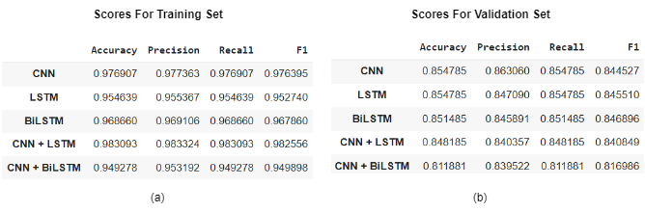

Table 5.1 - Accuracy, precision, recall and F1 scores for the neural networks. Table (a) shows the results for the training dataset, while (b) shows the results for the validation dataset.

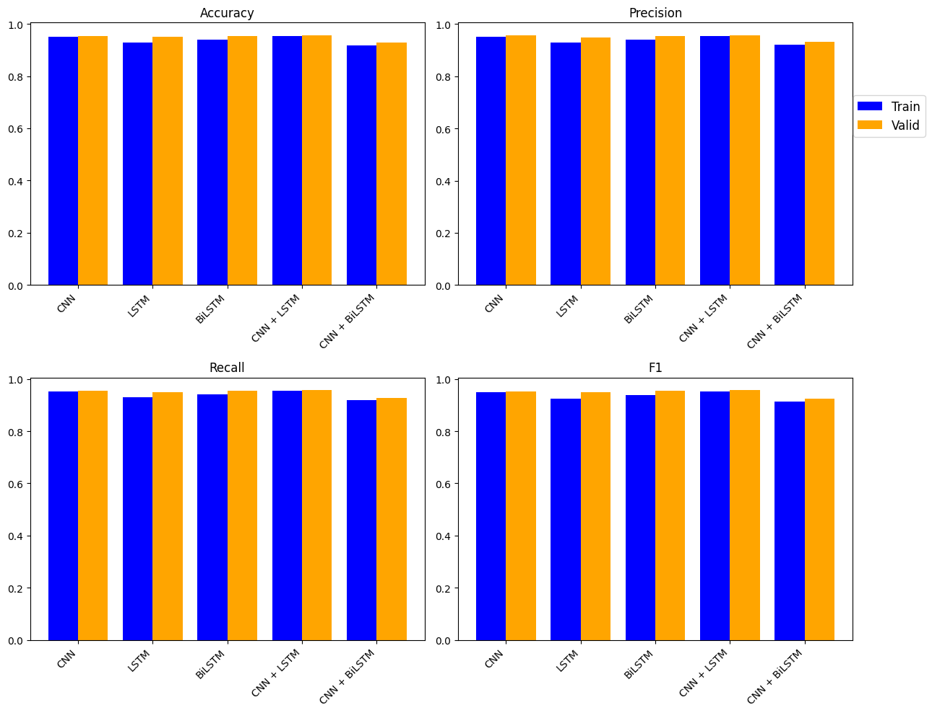

Figure 5.2 - The accuracy, precision, recall and f1 scores for the training and validation sets.

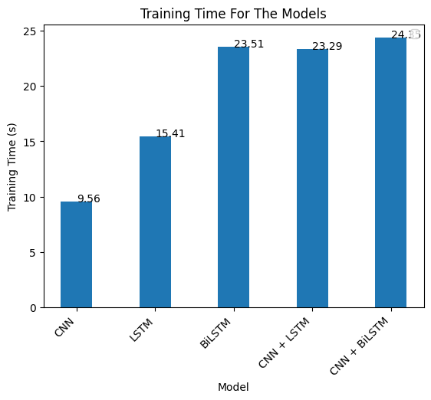

Figure 5.3 - Training time for each model.

The CNN + LSTM model combines the spatial feature extraction capabilities of CNN with the sequential modelling ability of LSTM. The model achieved high and consistent performance metrics on both the training and validation dataset (both tables show over 0.98 for the training dataset for all scores and over 0.84 for the validation dataset), suggesting it is appropriately fitted and does not demonstrate overfitting or underfitting. However, it took slightly longer training time compared to the traditional CNN and LSTM model.

Conversely, the CNN + BiLSTM model combines the spatial feature extraction capabilities of CNN with the bidirectional modelling of Bi-LSTM. The model also achieved high and consistent performance metrics on both the training and validation dataset(both tables show over 0.94 for the training dataset for all scores and over 0.81 for the validation dataset), suggesting it is also perfectly fitted. However it achieved the lowest scores among all the other models and took the longest time to train.

# 6. Conclusion

In the experiment, I tested five models, three of them used three non-hybrid algorithms (CNN, LSTM and BiLSTM) and two of them used hybrid algorithms (CNN + LSTM and CNN + BiLSTM). These five models were then evaluated using metrics such as F1-score, accuracy, precision, recall and specificity. Each model was evaluated using both the training and validation dataset. Hybrid models combining CNN with LSTM or Bi-LSTM show promising results, potentially offering a balance between spatial and sequential feature extraction. Despite this, CNN + LSTM emerges as the frontrunner in performance, thus recommended for tech companies seeking to predict customer sentiment. Nevertheless, the extended training duration of hybrid models, particularly when compared to baseline models like CNN and LSTM, warrants consideration.

# 7. Suggestions For Improvement

To improve the models, the choice of alternative word embedding techniques, such as Latent Semantic Analysis Encoding ([Gu, 2020](https://medium.com/sfu-cspmp/nlp-word-embedding-techniques-for-text-analysis-ec4e91bb886f)), and other preprocessing methods could further enhance the performance of these models. Investigating the problem using additional hybrid machine learning techniques, such as hyperparameter fine-tuning and other optimization methods could further improve the evaluation metrics scores. Moreover, exploring other evaluation methods such as k-fold cross validation ([Oyedele, 2023](https://www.tandfonline.com/doi/epdf/10.1080/27684830.2023.2201015?src=getftr)) and SHAP (SHapley Additive exPlanations) (Younisse et al., 2022, 1-20) could give more insight into the performance of each model. Also, given the difficulty of achieving 100% accuracy (due to the diversity of the English language), the hypothesis that sentiment analysis could be used to distinguish between humans and bots is worth considering.

# 

# Appendix

## Source Code

Click this [link](https://github.com/KemasRaihan/Analysis-Of-Common-Words-In-Customer-Reviews-Of-Phones-Using-Neural-Networks) for the Github repository for Jupyter Notebook source code along with the saved keras and h5 models.

Click this [link](https://github.com/KemasRaihan/Sentiment_Analysis_Customer_Reviews_Django) for the Github repository for the Django website source code..

# References

1. Adak, A., Pradhan, B., & Shukla, N. (2022, May 21). *Sentiment Analysis of Customer Reviews of Food Delivery Services Using Deep Learning and Explainable Artificial Intelligence: Systematic Review*. MDPI. Retrieved February 7, 2024, from https://www.mdpi.com/2304-8158/11/10/1500
2. Aggarwal, C. C. (2019). *Neural Networks and Deep Learning: A Textbook*. Springer International Publishing.
3. Ahmed, A. Z., & Rodiguez-Diaz, M. (2020, October). *Significant Labels in Sentiment Analysis of Online Customer Reviews of Airlines*. MDPI. Retrieved March 16, 2024, from https://www.mdpi.com/2071-1050/12/20/8683
4. AlQahtani, A. S.M. (2021, June). *Product Sentiment Analysis for Amazon Reviews*. Aircc Digital Library. Retrieved February 26, 2024, from https://aircconline.com/ijcsit/V13N3/13321ijcsit02.pdf
5. Annareddy, S., & Tammina, S. (2009, June 3). *Sentiment Analysis on Customer Reviews using Convolutional Neural Network*. IEEE Xplore. Retrieved February 6, 2024, from https://ieeexplore.ieee.org/stamp/stamp.jsp?tp=&arnumber=9104086&isnumber=9104045
6. Barker, S. (2024, January 23). *Can I Use Amazon Reviews On My Website: Guideline Explained*. TraceFuse. Retrieved March 17, 2024, from https://tracefuse.ai/blog/can-i-use-amazon-reviews-on-my-website/#is-it-legal-to-use-amazon-reviews-on-my-website
7. Berglund, M., Raiko, T., Honkala, M., Karkkainen, L., & Karhunen, J. (2015). *Bidirectional Recurrent Neural Networks as Generative Models*. NIPS papers. Retrieved March 18, 2024, from https://proceedings.neurips.cc/paper_files/paper/2015/file/c75b6f114c23a4d7ea11331e7c00e73c-Paper.pdf
8. Dang, C. N., Moreno-García, M. N., & De la Prieta, F. (2021, August 13). *Hybrid Deep Learning Models for Sentiment Analysis*. Hindawi. Retrieved February 15, 2024, from https://www.hindawi.com/journals/complexity/2021/9986920/#references
9. Graham, D., & Prince's, R. (2024, January 26). *Richard Prince ordered to pay damages to photographers in copyright infringement lawsuits over Instagram portraits*. The Art Newspaper. Retrieved February 19, 2024, from https://www.theartnewspaper.com/2024/01/26/judge-rules-against-richard-prince-copyright-infringement-instagram-portraits
10. Grossberg, S. (2013, December 13). *Recurrent neural networks*. Scholarpedia. Retrieved March 16, 2024, from http://scholarpedia.org/article/Recurrent_neural_network
11. GSMA. (2023). *The State of Mobile Internet Connectivity Report 2023 - Mobile for Development*. GSMA. Retrieved March 8, 2024, from https://www.gsma.com/r/somic/
12. Gu, F. (2020, February 3). *NLP: Word Embedding Techniques for Text Analysis | by Fangyug | SFU Professional Computer Science*. Medium. Retrieved April 26, 2024, from https://medium.com/sfu-cspmp/nlp-word-embedding-techniques-for-text-analysis-ec4e91bb886f
13. Haddi, E., Liu, X., & Shi, Y. (2013, May 16). *,*. ScienceDirect. Retrieved March 17, 2024, from https://www.sciencedirect.com/science/article/pii/S1877050913001385
14. Hand, D. J. (2020, July 31). *F*: An Interpretable Transformation of the F-measure*. arXiv. Retrieved March 20, 2024, from https://arxiv.org/abs/2008.00103
15. Hui, J. (2019, October 21). *NLP — Word Embedding & GloVe. BERT is a major milestone in creating… | by Jonathan Hui | Medium*. Jonathan Hui. Retrieved March 2, 2024, from https://jonathan-hui.medium.com/nlp-word-embedding-glove-5e7f523999f6
16. Iqbal, A., Amin, R., Iqbal, J., Alroobaea, R., Binmahfoudh, A., & Hussain, M. (2022). *Sentiment Analysis of Consumer Reviews Using Deep Learning*. MDPI. Retrieved February 6, 2024, from https://www.mdpi.com/1805800
17. Jain, P. K., Pamula, R., & Srivastava, G. (2009, June 3). *A systematic literature review on machine learning applications for consumer sentiment analysis using online reviews*. ScienceDirect. Retrieved February 6, 2024, from https://www.sciencedirect.com/science/article/pii/S1574013721000538?via%3Dihub#sec6
18. Kiritchenko, S., & Mohammad, S. M. (2018, May 11). *[1805.04508] Examining Gender and Race Bias in Two Hundred Sentiment Analysis Systems*. arXiv. Retrieved February 19, 2024, from https://arxiv.org/abs/1805.04508
19. Kwon, H., Ban, H.-J., & Jun, J.-K. (2021). *Topic Modeling and Sentiment Analysis of Online Review for Airlines*. MDPI. Retrieved February 6, 2024, from https://www.mdpi.com/2078-2489/12/2/78
20. Laricchia, F. (2023, July 21). *Smartphone sales worldwide 2007-2022*. Statista. Retrieved February 6, 2024, from https://www.statista.com/statistics/263437/global-smartphone-sales-to-end-users-since-2007/
21. Liu, B. (2020). 1 - Introduction. In *Sentiment Analysis: Mining Opinions, Sentiments, and Emotions* (pp. 1 - 17). Cambridge University Press. https://www.cambridge.org/core/books/abs/sentiment-analysis/introduction/563742A639EEE9F5AB3F29CB2387E41C
22. Mahmoud, M. H. (2009, June 3). *What is a kaggle?* Kaggle. Retrieved March 17, 2024, from https://www.kaggle.com/discussions/general/328265
23. McCallum, S., & Tidy, J. (2023, December 5). *23andMe: Profiles of 6.9 million people hacked*. BBC. Retrieved February 19, 2024, from https://www.bbc.co.uk/news/technology-67624182
24. Mulder, V., Mermoud, A., Lenders, V., & Tellenbach, B. (Eds.). (2023). *Trends in Data Protection and Encryption Technologies*. Springer Nature Switzerland. https://link.springer.com/chapter/10.1007/978-3-031-33386-6_2#citeas
25. Muntinda, J., Mwangi, W., & Okeyo, G. (2023, January 21). *Sentiment Analysis of Text Reviews Using Lexicon-Enhanced Bert Embedding (LeBERT) Model with Convolutional Neural Network*. MDPI. https://www.mdpi.com/2076-3417/13/3/1445
26. Nedjah, N., Santos, I., & de Macedo Mourelle, L. (2023, January 6). *,Sentiment analysis using convolutional neural network via word embeddings*. Springer Link. Retrieved March 16, 2024, from https://link.springer.com/article/10.1007/s12065-019-00227-4#Sec5
27. Obiedat, R., Qaddoura, R., Al-Zoubi, A. M., Al-Qaisi, L., Harfoushi, O., Alrefai, M., & Faris, H. (2022, February 07). *Sentiment Analysis of Customers’ Reviews Using a Hybrid Evolutionary SVM-Based Approach in an Imbalanced Data Distribution*. Sentiment Analysis of Customers’ Reviews Using a Hybrid Evolutionary SVM-Based Approach in an Imbalanced Data Distribution. Retrieved February 7, 2024, from https://ieeexplore.ieee.org/document/9706209
28. Oyedele, O. (2023, November 9). *Determining the optimal number of folds to use in a K-fold cross-validation: A neural network classification experiment*. Taylor & Francis. Retrieved April 26, 2024, from https://www.tandfonline.com/doi/epdf/10.1080/27684830.2023.2201015?src=getftr
29. Pennington, J., Socher, R., & Manning, C. D. (2014). GloVe: Global Vectors for Word Representation. *GloVe: Global Vectors for Word Representation*. https://nlp.stanford.edu/pubs/glove.pdf
30. Prananda, A. R., & Thalib, I. (2020). Sentiment Analysis for Customer Review: Case Study of GO-JEK Expansion. *Sentiment Analysis for Customer Review: Case Study of GO-JEK Expansion*. https://www.researchgate.net/publication/341079068_Sentiment_Analysis_for_Customer_Review_Case_Study_of_GO-JEK_Expansion
31. Priyadarshini, I., & Cotton, C. (2021, May 19). *A novel LSTM–CNN–grid search-based deep neural network for sentiment analysis*. SpringerLink. Retrieved February 6, 2024, from https://link.springer.com/article/10.1007/s11227-021-03838-w#Sec19
32. Punetha, N., & Jain, G. (2023, March 31). *Game theory and MCDM-based unsupervised sentiment analysis of restaurant reviews*. Mendeley. https://www.mendeley.com/reference-manager/reader-v2/27779f07-3a82-35ce-896a-e75da7ec5614/0e1acc39-614e-1cc1-50df-dc75c1e1321d
33. Pykes, K. (2020, November 25). *Part Of Speech Tagging for Beginners | by Kurtis Pykes*. Towards Data Science. Retrieved March 20, 2024, from https://towardsdatascience.com/part-of-speech-tagging-for-beginners-3a0754b2ebba
34. Sak, H., Senior, A., & Beaufays, F. (2014). *Long Short-Term Memory Recurrent Neural Network Architectures for Large Scale Acoustic Modeling*. Google Research. Retrieved March 16, 2024, from https://static.googleusercontent.com/media/research.google.com/en//pubs/archive/43905.pdf
35. Spring Nation. (2023, January 6). *,*. Springer. Retrieved March 11, 2024, from https://link.springer.com/article/10.1007/s42979-021-00815-1
36. Talaulikar, A. (2020). *GloVe Embeddings + BiLSTM Sentiment Analysis*. Kaggle. Retrieved February 28, 2024, from https://www.kaggle.com/code/abhijeetstalaulikar/glove-embeddings-bilstm-sentiment-analysis
37. Trends and Surveys. (2023, November 23). *Sentiment analysis using deep learning techniques: a comprehensive review*. SpringerLink. Retrieved February 7, 2024, from https://link.springer.com/article/10.1007/s13735-023-00308-2
38. Younisse, R., Ahmad, A., & Abu Al-Haija, Q. (2022). Explaining Intrusion Detection-Based Convolutional Neural Networks Using Shapley Additive Explanations (SHAP). *Big Data and Cognitive Computing*, 1-20.
39. Zhan, J., & Fang, X. (2015, June 16). *Sentiment analysis using product review data - Journal of Big Data*. Journal of Big Data. Retrieved February 6, 2024, from https://journalofbigdata.springeropen.com/articles/10.1186/s40537-015-0015-2#citeas